Date: 14.05.2021
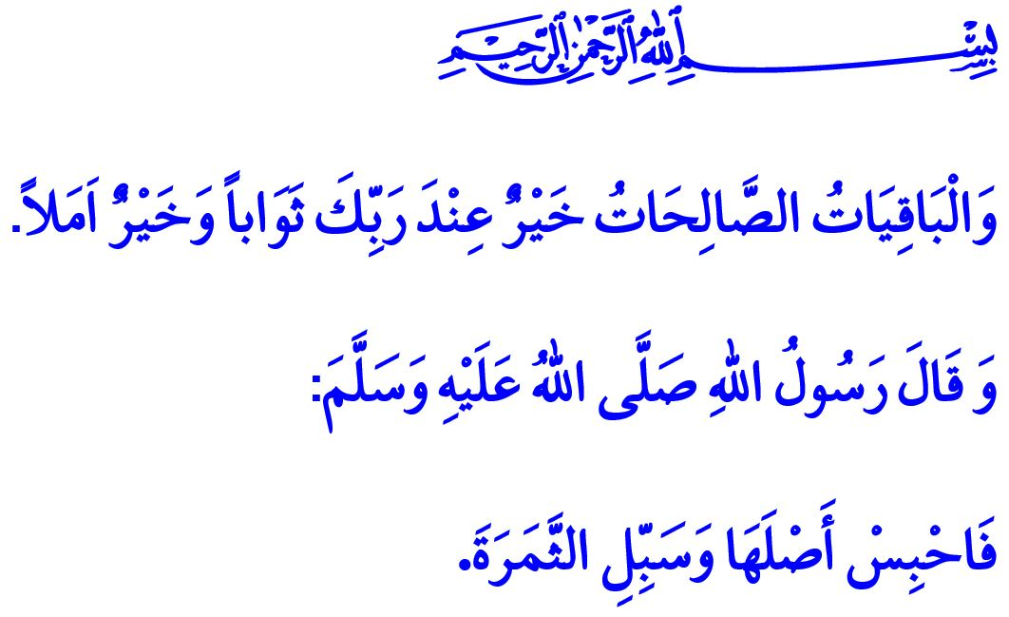
WAQF: THE CIVILIZATION OF COMPASSION AND MERCY
Honorable Muslims!
One day, the Prophet Muhammad (saw) said to his companions, “When a man dies all his good deeds come to an end except three: sadaqah jariyah (ongoing charity), beneficial knowledge and a righteous son who prays for him.”
One of the best examples of sadaqah jariyah mentioned in this hadith are the awqaf (foundations) that are the symbol of the Islamic civilization.
Dear Believers!
Waqf is the institutionalized form of the compassion and affection of Islam towards all existence. It is about putting to the service of all humanity, in fact all living beings, any property and wealth entrusted to humans. It is about holding the hand of the weak and the fallen, and offering a lasting solution to the problems of those in need. In this respect, on one occasion, when Umar (ra) came to the Prophet Muhammad (saw) and said, “O Messenger of Allah! I have a garden of date-palms which I prize highly. I want to give it in charity.”, the Messenger of Allah (saw) made the following recommendation for him, “Endow it, and spend its fruits in charity.”
Dear Muslims!
Our forefathers viewed endowments as “institutions of loyalty” and put the wealth they acquired into the service of humanity again. With this understanding, they built many works such as mosques, masjids, schools, madrasas, libraries, hospitals, public kitchens, fountains, bridges, etc. That way, they provided jobs for the unemployed, food for the poor, relief for the indebted, home for the homeless, and healing for the sick. They enabled benevolence to prevail on the face of the earth with the motto “Brotherhood knows no borders or boundaries”, and became home to the oppressed, and a hope to the miserable. It is not only people but also the unattended animals, the nestless birds, and even the birds of prey who enjoy their share from this deep compassion and grace of Islam.
Dear Believers!
Our Lord Almighty (swt) states in the Holy Qur’an as follows, “The enduring good deeds are better to your Lord for reward and better for [one’s] hope.”
Therefore, let us view the temporary worldly blessings as means to ensure that our book of deeds remains open for new entries eternally. Let us offer contributions to the establishment, maintenance, and betterment of awqaf. Let us not forget that it is compassion that lies in the heart of the waqf civilization. Compassion, moreover, is the manifestation of the names al-Rahman and al-Rahim of Allah the Almighty (swt).
Dear Brothers and Sisters!
The oppressors, who know no rights or laws and lack mercy and conscience, are continuing to occupy the soils of our Palestinian brothers and sisters and attack bestially without discriminating children, the elderly, or the women. Let us open our hands to beg in praying to our Lord (swt) in this hour when prayers are accepted:
O Allah! You are the guardian of the lonely, and the shelter of the oppressed; treat us with Your mercy.
You are our Protector, help us against oppressors.
O Allah! For the sake of these blessed days, save our first qiblah, the Masjid al-Aqsa, and the city of prophets, al-Quds, from the occupation of the oppressors!
O Allah! Enable us and all Muslims around the world to strive for protecting the Masjid al-Aqsa, the first step to the miʻraj.
O Allah! Grant salvation to all oppressed Muslims forced out of their homes and lands who have become miserable in their own homeland.
Protect our heavenly homeland and our great nation, the hope of the oppressed and the home of the miserable, from all kinds of dangers, o Allah!

Muslim, Wasiyyah, 14.
Muslim, Wasiyyah, 15.
Kahf, 18/46. General Directorate of Religious Services

